Comprehensive Creative Technologies Project: Manipulating a Narrative: Leveraging Cinematography for Effective Digital Marketing

**Luke Hammond**

[Luke2.hammond@live.uwe.ac.uk](mailto:Luke2.hammond@live.uwe.ac.uk)

Supervisor: Richard Wakeling-Gentle

Department of Computing and Creative Technology

University of the West of England  
Coldharbour Lane  
Bristol BS16 1QY

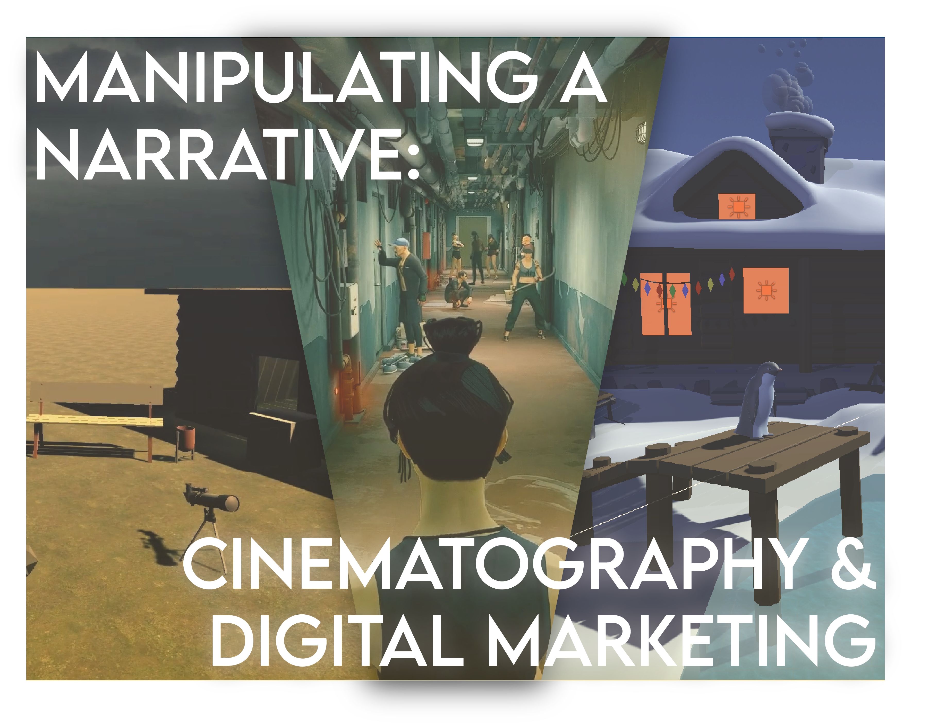

**Abstract**

This project demonstrates the ability of digital marketing and cinematography working collaboratively to influence a narrative perceived by an audience. This was done through creating videos using SIFU & Unity before being edited in Premier Pro & After Effects. The final output of this project was an advertisement created for a fictional charity, *Free From Captivity*. The goal of this project is to support findings in both collective fields as well as produce more results towards that by showcasing suitable user experience methodologies. Results garnered from this project clearly indicate that cinematography and digital marketing can work in combination to produce a narrative that fulfil a business intended output. This can be seen as nine out of ten people, believe the final artifact accurately fulfilled its purpose of influencing a narrative.

**Keywords**: cinematography, digital marketing, marketing, user experience, unity, post-production, propaganda, advertisement

**How to access the project**

**Final Video:**

* Video discussing the project - <https://youtu.be/kalZp5LBFvY>

**Initial Artifact Videos:**

* Original SIFU Scene - <https://www.youtube.com/watch?v=vM22u9yPy_0>
* 1 - <https://www.youtube.com/watch?v=1Ds4mfHNtvA>
* 2 - <https://www.youtube.com/watch?v=GUsEXRDlNnc>
* 3 - <https://www.youtube.com/watch?v=APUiMnt7X1Q>
* 4 - <https://www.youtube.com/watch?v=R2Q2DgPWPGs>
* 5 - <https://www.youtube.com/watch?v=JY6Sq4R1WvM>
* 6 - <https://www.youtube.com/watch?v=n_AbAkTIJec>
* 7 - <https://www.youtube.com/watch?v=CvZMY-aaqaE>

**Air Pollution/Industry Videos:**

* Anti Industry - <https://www.youtube.com/watch?v=a8GaxVqelT4>
* Industry - <https://www.youtube.com/watch?v=hVHsHJ5dxh4>

**Free From Captivity Advert:**

* Zoo Scene - <https://www.youtube.com/watch?v=mTy0sOMDSu0>

**Notion:**

* Project Blog - <https://shadow-shadow-7bf.notion.site/CCTP-Blogs-139eec841de340e4a5a7685eedff816a>

**GitHub:**

* Unity Scene Files - <https://github.com/RandumbFluke/CCTP-Unity-Scenes>

**1. Introduction**

The project explores how cinematography can work in collaboration with marketing skills and tactics to produce an effective piece of media to either demonstrate an ideology or sell a product. The significance of researching into various aspects of cinematography is to access which element can draw the most emotional response when desired.

Emotion is a key part of user experience (UX) and marketing which can allow for the best and most accessible product (Thomas, 2020). This is imperative as the project is looking to gain an emotional connection with the users/customers, in an attempt to influence their thought process in favour of one particular product.

A lot of digital marketing is in the form of blogs, or graphic pieces such as posters dedicated towards digital upload rather than print(Thomas, 2020). However, with the rise in video and its more accessible nature it is coming to the forefront but is still outshone by older forms of marketing (Chaffey, Ellis-Chadwick, 2022). Therefore, the ultimate result of the project is whether cinematic elements can be used to engage support or whether the more traditional marketing tactics are more influential even in a cinematic piece.

Additionally, the project is geared towards being very UX central with heavy reliance on engaging with participants for primary research. The primary research collected will work alongside pre-existing secondary research to further reinforce the content, providing new evidence to support initial findings.

* 1. **Deliverables**
* Documentation of user testing and secondary research
* Unity scene animations created for advertisement
* Videos to demonstrate secondary research
* Project blog
* Final advertisement

**1.2. Project objectives**

* Showcase how media can be manipulated to display one point of view
* Collect and record data from user testing
* Create a scene developed from a storyboard
* Drawing conclusions from primary research
  + Create visual representations of data
* Implement ideas from the field of marketing

**2. Research questions**

All research questions work towards the final objective of creating an advertisement piece that leverages elements of cinematography and digital marketing. These questions provide objectives to work towards during the production of the final artifact.

* How to create a narrative story using cinematography, specifically: camera angles, colour, lighting, aspect ratio, editing and sound. Additionally, how do they portray and manipulate emotions?
* How significant is the use of post-production in encompassing these elements in the creation of a final product?
* What is the most effective method of user testing to produce qualitive and quantitative results which can be analysed and represented in a variety of forms such as pie charts, data matrices, etc?
* What is the most accessible formatting of research which can allow collaboration with existing secondary research?
* What are the existing forms of digital marketing and how does cinematography rank?
* How can cinematography be seamlessly implemented to create a piece that works as a successful alternative to existing marketing formatting?
* What is the difference between traditional marketing compared to digital marketing and which approach is most fitting towards cinematography and its implementation?

**3. Literature review**

The research conducted for this project covers some of the main principles of cinematography and their role in creating a cinematic piece. Additionally, investigation into marketing tactics was equally studied as well as previous examples of it in the form of propaganda.

**3.1. Cinematography**

Following the research findings for the project, it was clear that many of the sources were accurate in their interpretation of cinematic elements and their influence upon audience emotions. This also highlighted a natural priority list of which factors were more important in resulting in emotional responses. This shows clear indication which elements may need uplifting to provide more influence in the final artifact but also the elements that are essential to the creation of an emotional piece and need the most attention.

**3.1.1. Camera angles & framing**

Framing is one of the basics for cinematography but is a significant element in creating an innovative and creative piece (StudioBinder, 2020). Framing is used to isolate and focus attention on what we are looking at (StudioBinder, 2020), allowing for tension but also drawing focus from the audience. However, framing isn’t solely geared towards cinematography but can also be found in art. Edward Hopper is an example of an artist who often shrinks the subject to occupy only a small portion of the framing allowing their surroundings to engulf them (DefinitelyOwen, 2016). This allows cinematography to equally take inspiration from art pieces as well as similar videos in the medium.

While shot size and framing as discussed are utilised to isolate what we are looking at. Camera angles are geared towards creating a perception for the audience to view them through, providing another layer of meaning to the video (StudioBinder, 2020). Camera angles come in a variety of forms allowing the subject to be interpreted from a wide range of emotions based on how the camera is positioned for example, close-ups provide a level of connection as the audience is able to immerse themselves within the tension felt when facing off against the character on screen.

**3.1.2. Colour**

“Colour can affect us emotionally, psychologically and even physically, often without us becoming aware,” (Risk, 2020) inherently humans are drawn to colours and through media as well as our natural environment have come to perceive specific colours to symbolise/represent certain emotional responses. One such example is the colour red with connotations to danger in the Middle East whereas in China, red symbolises luck and happiness (EriksenTranslations, 2020). If a scene is created predominantly with consistent features, the implementation of cooler tones, can create a scene that feels sinister and suspenseful. Whereas warmer tones, can create a sense of relief and relaxation (Creative Path Films, 2020).

This knowledge is then used and translated into cinematography, classic screen theory states that colour can heighten the emotional impact of a scene (Frierson, 2018). Utilising the main aspects of colour; hue, brightness, saturation and contrast, a cinematic piece can convey numerous emotions even from the same scene. Therefore, colour can be manipulated to reflect the mood of a scene and personality of its occupants (Jackson, 2010), for instance a dark drabby scene may be occupied by our protagonist decorated in a bright pink showcasing that even in such a dark world they are the last shining ray of hope.

The use of such a powerful tool allows the director to skip exposition and can allow the audience to instinctively analyse the emotional thoughts and feelings of an area or subject without being explicitly told what they are. When working in unison with camera angles it enhances a scene for the audience, after all, a picture is worth a thousand words.

**3.1.3. Lighting**

Lighting, like colour can be broken down into various forms. The focus for this project is ambient lighting, practical lighting and motivated lighting. Ambient lighting is found naturally in a scene such as streetlamps or sunlight, which provide a sense of realism to the scene enabling a connection to be established with the audience’s familiarity to as setting. Practical lighting refers to any light source that can be seen in the frame. Motivated lighting means there is a logical or reasonable justification for the light in a scene such as external lighting to help an audience potentially see in a dark scene. (StudioBinder, 2022). Lighting is often used to produce or enhance colours on a scene, therefore colour and lighting work collaboratively to help determine the mood of a scene (Jackson, 2010).

Cinematographers measure colour temperature, in units called Kelvins. These units work along a spectrum which at certain intervals can produce a variety of colours to help intensify a scene (StudioBinder, 2022).

Utilising this knowledge, the lighting team must find the balance between light and shadow, also known as the contrast ratio. “High-key lighting is a term that expresses a low contrast ratio… Low-key lighting on the other hand uses a high contrast ratio.” (StudioBinder, 2022). Therefore, high-key lighting is used for brighter and happier scenes due to the ability to emulate sunlight and reduce darkness within a scene. Whilst low-key lighting is used for more sinister and dramatic scenes as it simulates nighttime in movies – this is heavily used in more noir and horror style movies (Jackson, 2010). The significance of such methodology is the ability to create emphasis and a focal point for the audience to engage with, this technique can transform a complex scene with many details into one that is easy to read and understand (Jackson, 2010).

**3.1.4. Aspect ratio**

Aspect ratios are not confined to how a video must be shot, it can be morphed and changed inside of the scene. Aspect ratios could make someone feel very claustrophobic and tight within a scene or it can make you scenery feel massive and overwhelming, there are many different ways to convey a message with it (Tomorrows Filmmakers, 2018). A famous example is in the Hunger Games when Katniss who the audience has been viewing in close-ups with a tight black border first arises into the games. During her ascent the borders proceed to open and convey the vastness of the area and the magnitude of the task ahead, while also implying the insignificance of her existence in such an area.

A shift in aspect ratio should be subtle in motion so it isn’t obvious but still registers in the audience’s mind (Tomorrows Filmmakers, 2018). In this case the border opening emphasises the uncomfortable feeling in the audience but also implies they are just another onlooker alongside the many others in the world of the Hunger Games.

**3.1.5. Editing**

Editing or post-production is where the narrative comes to fruition, “the editor takes source footage and turns up the art.” (Frierson, 2018) However, editing follows its own rules and many editors have their own style, for Murch, emotion, is at the top of the list, it is the thing that you should try to preserve at all costs. (Murch, 2001) This is similar to the approach of the project due to the goal of having users connect with the final piece and draw emotional connections with it. Murch goes on to say, “if you have to give up something, don’t ever give up emotion before story,” clearly demonstrating the significance of an emotional connection with the audience.

To keep emotion at the forefront, editors must create a piece that flows seamlessly from scene to scene without ruining the concentration of the audience. Dmytryk states, the editor should change the shot only if the change improves the scene – there must be a positive reason for the shot change (Frierson, 2018). When this concept is working in association with smooth cuts and rhythm it creates a naturally flowing piece.

This links to Pearlman’s ideas that “editors use their innate “kinesthetic empathy” or “corporeal imagination” to read the rhythm in rushes, and their own bodies to write filmic rhythm” (Frierson, 2018). In other words, editors naturally empathise with an audience and create a piece that will sustain immersion from their own inherent need to have a piece that does so. This links to Dmytryk’s previously stated idea of creating a natural flow to the edit by switching scenes when necessary, maintaining a smooth emotional narrative.

**3.1.6. Sound**

Editing and sound work together to create a believable narrative but also emphasise elements of the story. Sound can be broken down into two elements, diegetic or non-diegetic. Diegetic sounds refer to sounds that are found within the scene whether that is on or off-screen. Whereas non-diegetic sounds are only heard by the audience members and not the characters on screen (BBC Maestro, 2023). An example of this is music. While it can be diegetic it is very often non-diegetic and used as a tool to heighten emotion of the scene (Frierson, 2018). Therefore, Yang and Chen believe, “music cannot be composed, performed, or listened to without affection involvement” (Yang, Chen, 2011). Similar to colour, music from as far back as human history has been used to symbolise moods or evoke emotions. However, music is arguably more subjective. For Yang and Chen emotions found in music studies are often broken into “expressed emotion, perceived emotions and felt (or evoked) emotion.” In literal terms, the former is what the artist wants to express to the listener while the other two refer to how it is perceived (Yang, Chen, 2011).

While music is an influential tool in cinematography, it needs grounding with visual elements, particularly colour. “Music perception is intrinsically subjective and is under the influence of many factors such as cultural background, age, gender, personality, training, and so forth” (Yang, Chen, 2011). When working in conjunction with visual elements, music and sound easily elevate emotional responses garnered from the visual stimulant of cinematography.

**3.2. Marketing**

The final part of the project is leveraging cinematography for effective digital marketing. The project, therefore, must have an established definition of “Marketing.” This project heavily follows Thomas’ Watertight Marketing book which reiterates marketing, and emotions work intrinsically with one another. “Having an emotional connection can be all-important in getting people over that final hurdle.” She further states, emotion is arguably the most important because it begins and ends the process. Additionally, it is also powerful because it’s something that happens to users, beyond their conscious control (Thomas, 2020).

Combining this ideology alongside the cinematic elements previously discussed, emotion is the key factor to building a bridge between these two elements. Thomas, slightly lays out a narrative which can easily be accentuated by cinematography, “what you need is an interlinked series of messages that starts with emotion, move on to logic and then return to emotion.” Previous statements have been reminiscent of this quote from Thomas and shows the possibility of cinematography being effective for marketing.

However, video isn’t the only media piece for marketing, one successful example of effective marketing is the use of poster propaganda. Propaganda is notoriously considered negative, with bad implications. However, as Miller states, “’Propaganda’ in its proper meaning is a perfectly wholesome word, of honest parentage and with an honourable history.” Miller argues, this thinking has since changed and is now as simple as “let another group of citizens express opposing views, and they are promptly labelled with the sinister name of propaganda” (Berneys, Miller, 2005).

Propaganda, defined by the oxford dictionary means, “information, especially of a biased or misleading nature, used to promote a political cause or point of view.” This definition has very strong implications to marketing due to wanting to build an “emotional connection,” as Thomas states, “positive and negative emotions… can make an excellent basis for your messaging.” While all media is biased in one way or another so is marketing due to the need of wanting to sell a product or ideology to a user, “something doesn’t need to be a lie to become propaganda, it doesn’t need to be from the government, and it doesn’t need to be about a country being the root of all evil” (Second Thought, 2023). Propaganda is arguably all around but is only noticed when done incorrectly, this is where marketing is used to steer it towards a focus customer group, and ultimately is accomplished through methods like cinematography due to the seamless intake of information from an audience. As Bernays states, “If the public becomes more intelligent in its commercial demands, commercial firms will meet the new standards.”

**4. Research methods and ethics**

The methodology for answering the research questions will be established methods used in the field of UX. These will involve user testing in the form of voice recorded interviews conducted individually or in a focus group. This is due to focus groups often bringing out users’ spontaneous reactions and ideas (Nielsen, 1997). Additionally, interviews allow you to discover what a user really thinks as you gain access to their inner thinking (Nielsen, 2012). The project will also conduct a survey created on Google Forms. While creating questions, care was taken to avoid influence or guidance for user answers and thus most responses remain unbiased as much as possible.

The initial round of user testing contained a sample size of fifteen participants including focus groups. Findings have been presented in a research findings documentation.

As for the surveys this will be a more concentrated group of ten individuals to outline the definitive result of the project. This will provide a qualitative set of data due to questions being focused on specific cinematic and marketing techniques. Before the survey stage, a pilot test will be conducted to determine whether the questions and artifact need altering. The findings of this will be revisited further in the report.

The research conducted for this project were ethically approved via UWE Bristol’s Faculty Research Ethics Committee. All participants before signing a consent form were required to read through a GDPR form as well as an information sheet regarding the project. This was also the case for the Google Forms survey conducted. Data collected via voice recordings were anonymised under new titles such as Participant A, Participant B, etc. Once each voice recording had been transcribed for the data matrix, they were soon deleted. Users are allowed to withdraw from the project at any time whether that is in present day or in the future. In regard to Google Forms, all answers are instantly anonymous so nobody viewing will be able to pinpoint who responded in what manner.

Music and sound effects for videos were gained from Pixabay, licensed under the Creative Commons Zero (CC0) licence (CC0 Content) (pixaby, 2024).

**5. Practice**

During the process of the project a few issues had to be overcome to produce the desired outcome. This involved problem-solving, changing strategies/approaches to certain aspects of the project as well as learning new techniques to gain the most out of artifacts.

**5.1. Initial artifact**

The projects first goal was confirming and supporting the conducted secondary research through the creation of a series of videos demonstrating cinematic elements. The video was originally to be created in Maya, which would allow for control over lighting, camera angles as well as movements of the scene. Each scene was storyboarded via a screen capture from Hogwarts Legacy. However, due to a technical issue in importing assets, the idea was soon scrapped, and a new software was chosen. Although, this new software/idea had to emulate as much freedom that Maya provided, the project therefore had to decide its next direction from the following:

• Creating the assets from scratch – however the artifact is not meant to demonstrate the authors 3D modelling abilities and with thus slow the process of the project.

• Creating a scene in Unity – while ideal towards the project’s goals, the author was in an understanding that only a first-person point of view could be displayed.

• Creating the scene in a game – many games have the ability to replay but don’t provide functionality towards changing lighting outside of post-production.

• Creating the scene in-person – a very difficult solution due to the need for equipment and personal to record the scene as well as reliance on environmental conditions.

• Recreating a trailer from pre-existing post-production clips – would not suit the brief due to clips having received existing post-production treatment.

The alternative software chosen was a game called SIFU (Sloclap, 2022), this was chosen due to the theatre/playback mode. Thus, allowing for the creation of cinematic pieces (see Fig 1).

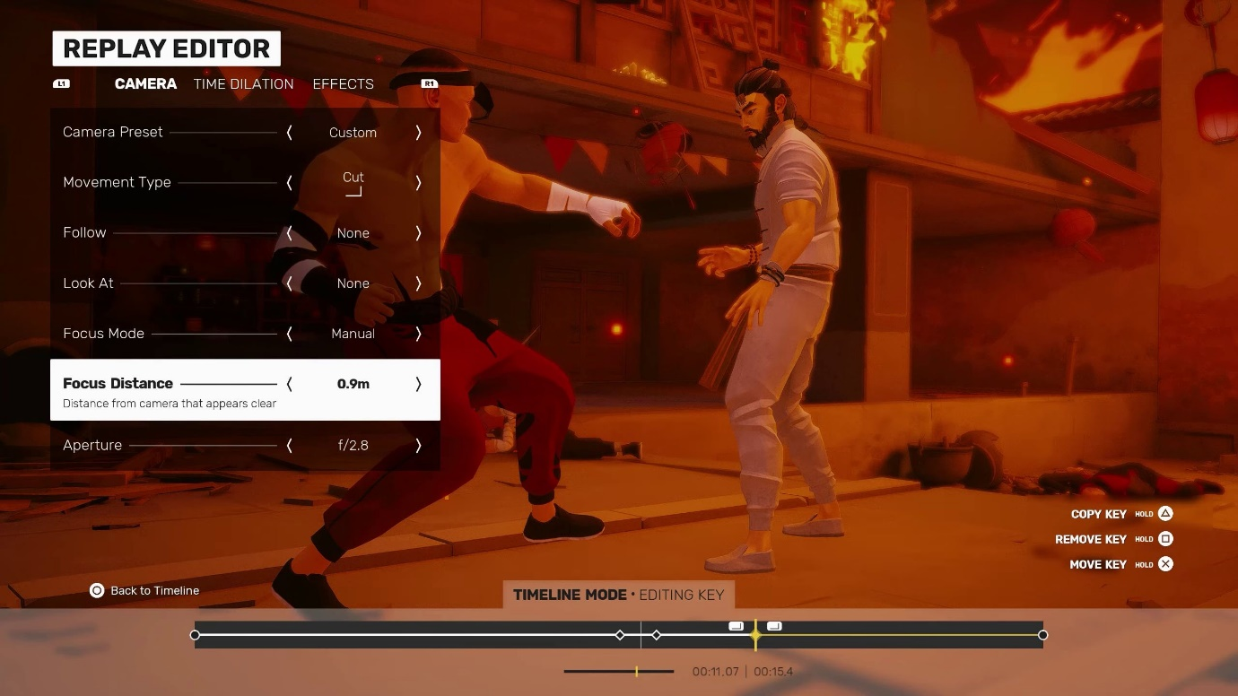

**Fig 1:** SIFU Replay Editor

However, the game has limitations such as lighting control or the most obvious problem, it has a pre-established genre. The original Maya creation was a simple storyboard of a character walking down a flight of stairs before entering a grand hall, a rather genre neutral piece. Whereas SIFU is inherently an action, martial arts fighting game, resulting in all scenes being action heavy.

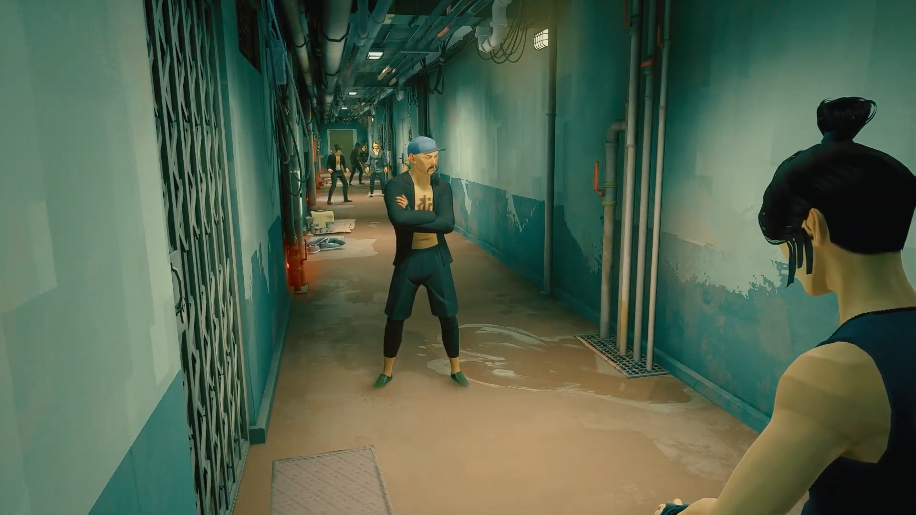

**Fig 2:** Original SIFU Scene

As seen in Fig 2, the cool colours of the game imply sinister undertones as established in section 3.1.2, this is reinforced by the grimy environment. This posed a challenge in the project as displaying elements of the romantic genre as an example, would be a subversion of the action displayed. However, the project took the approach of using such challenges as a way to reiterate the research and instead confirm the significance of cinematic elements such as colour and sound (see Fig 3).

To keep all the footage on equal standing, all eight videos shown to participants in user testing followed the same sequence of events with the same camera angles. This resulted in videos with specific elemental changes such as colour, lighting and sound added in post-production.

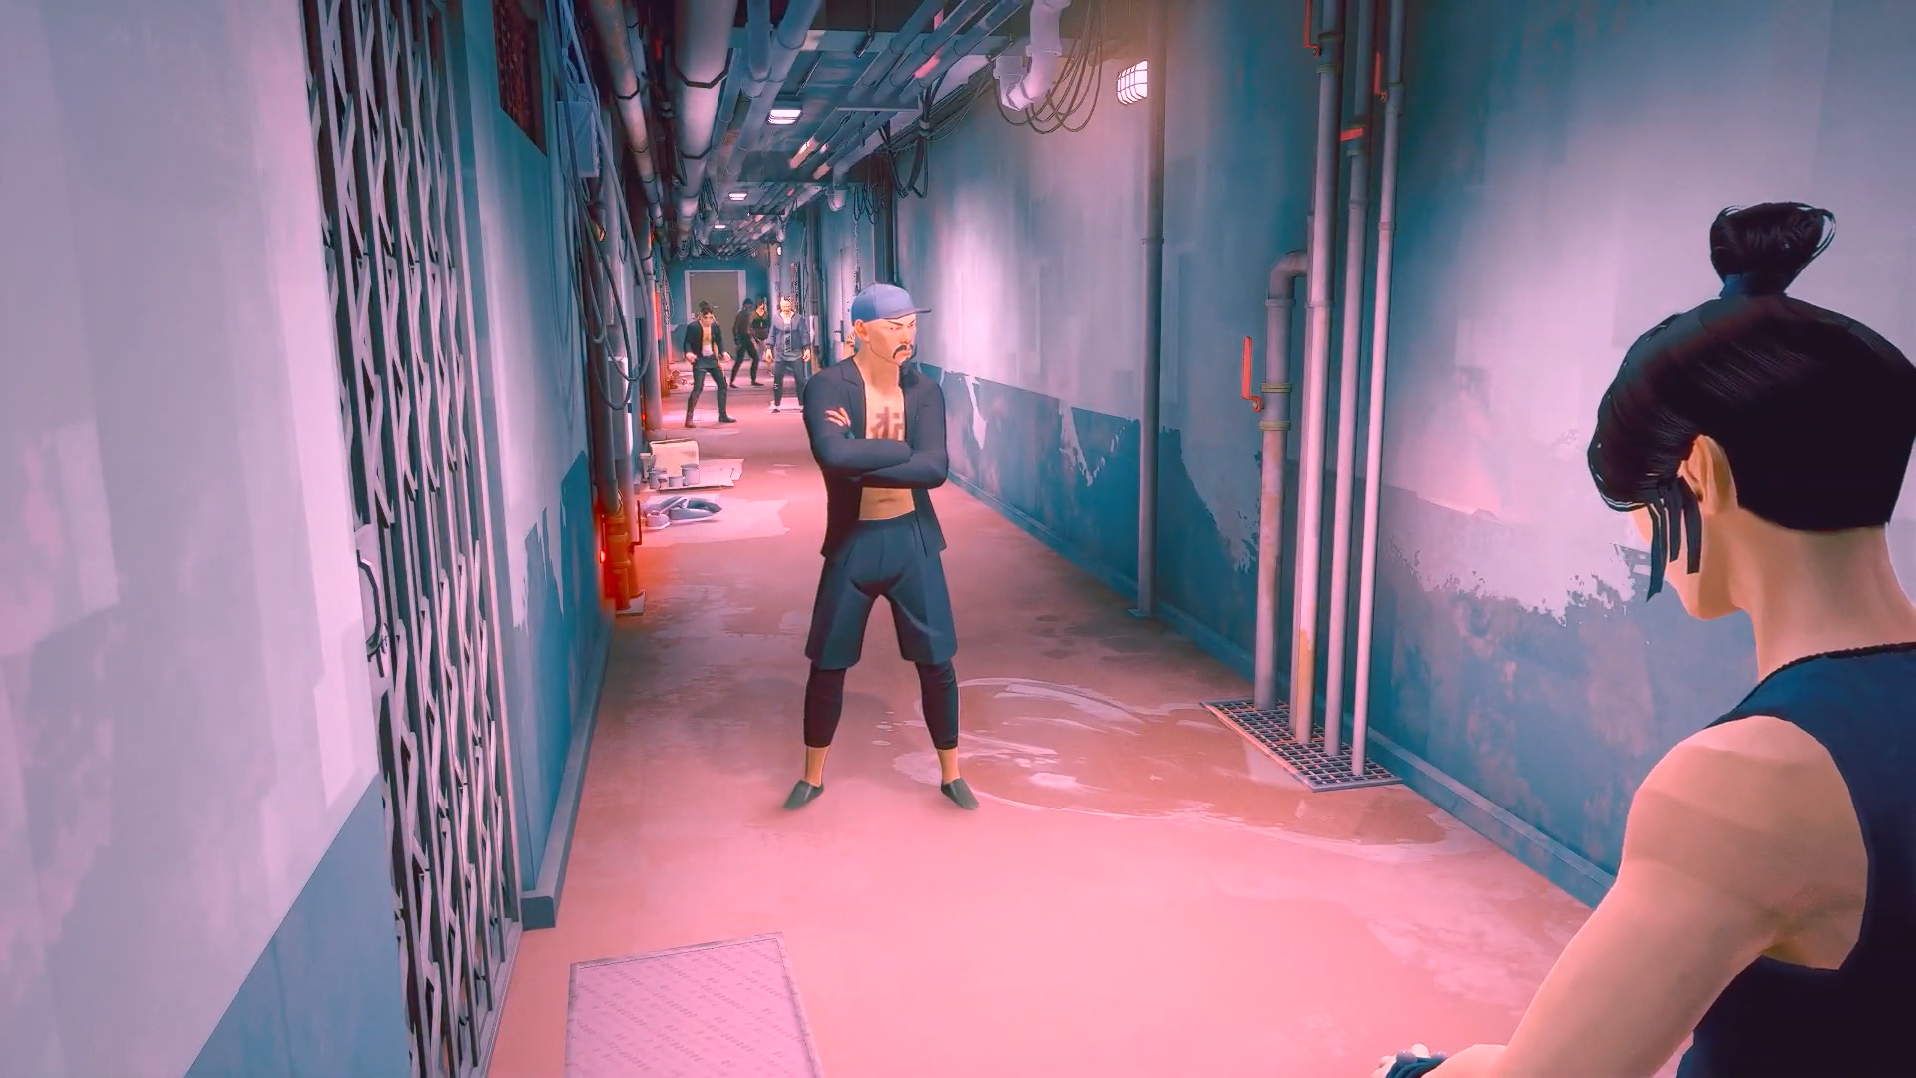

**Fig 3:** SIFU Scene After Post-Production

The final consideration for using SIFU was the age rating being PEGI 16. As a result of this, all participants for user testing were required to be of the age of sixteen, however this was soon changed to eighteen, once videos had been rendered after post-production due to dark undertones in certain videos.

**5.2. User testing**

As mentioned previously, the first round of user testing was to assess whether the research gained was of valid use. To engage with the participants, they were partaking in interviews as well as asked to speak aloud when viewing videos. Questions were geared towards enjoyment, feeling and thoughts towards cinematic elements. As a conclusive end to each video, all participants were given a chance to guess the intended genre for the videos. The intent of this question was to assess whether the cinematic elements fulfilled their intended purpose. To showcase the results of user testing pie charts and data matrices were created to be compiled into a user testing document.

For many participants the action was neutral to the genres appeal due to heightened cinematic elements balancing the scene. This was evident in Video 3 (see Fig 4), where Participant D stated, “it didn’t feel as serious even though the action was still there. The lighting and the music made it rather jolly.” The idea that if one element is oversaturated with detail, can counter another was an interesting thought process and appeared commonly throughout the view time of other videos. This means, if a video was created to reflect horror in its colouring but the sounds were more comical in nature. The oversaturation in sounds could affect a user’s perception of the genre to be more comical than horror based.

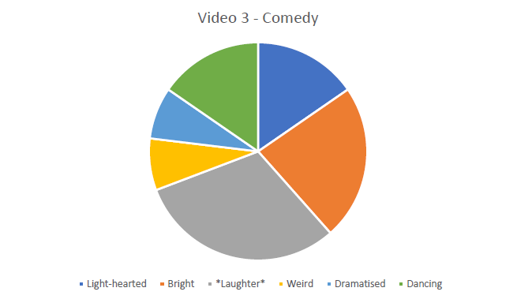

**Fig 4:** Pie Chart for Video 3 – Comedy

Another factor that became clear was to not underestimate the audience in their understanding of screenplay and cinematography. Audiences will put up with a lot of change or momentum shifts as long as it makes sense by the end of the sequence. This can be seen with video 5, the no genre video. Video 5 invoked a lot of thoughts and feelings during the interviews but also while watching. According to Participant F, “I didn’t quite understand what I was watching, and I ended up getting caught trying to figure out what I was watching rather than watching.” This was due to the jump between colour and greyscale as well as the music changing in accordance with the colour. While the confusion was very apparent (see Fig 5), Participant C stated, “it caught my interest, but I was still confused.” This confusion was due to visual and audio changes of elements happening on the screen, but many concluded it was juxtaposition to demonstrate a dream state against reality.



**Fig 5:** Images from Video 5 demonstrating the contrast between scenes

The project had now acquired data in the form of primary research that not only supported and reflected secondary research but allowed for the project to move towards its final artifact with data to reinforce future choices.

**5.3. Unity**

During the mid stages of the project, it became apparent the project needed an artifact created from beginning to end, to showcase cinematic elements in their optimal use. Due to falling short of doing so with the first artifact, the second and final artifact, which holds the intention of bringing all the elements together needed a software such as Maya or Unity. Unity was selected as the designated route due to the accessibility it gives with the use of assets and libraries pre-installed. As the project is predominantly focused on cinematic elements rather than the on-screen movement, Maya was not selected as a choice due to its main usage around 3D modelling and animation.

Cinemachine is a convenient tool for creating short animations within Unity due to its ability to house multiple forms of camera angles such as a dolly camera angle to the freedom of creating a dutch angle. It made all shots possible, especially some possibly considered hard in a real-world setting such as arial establishment shots, due to the need of funding. After following a few tutorials, the researcher soon paired Cinemachine with the Timeline package to begin recording the created scenes, using Unity assets.

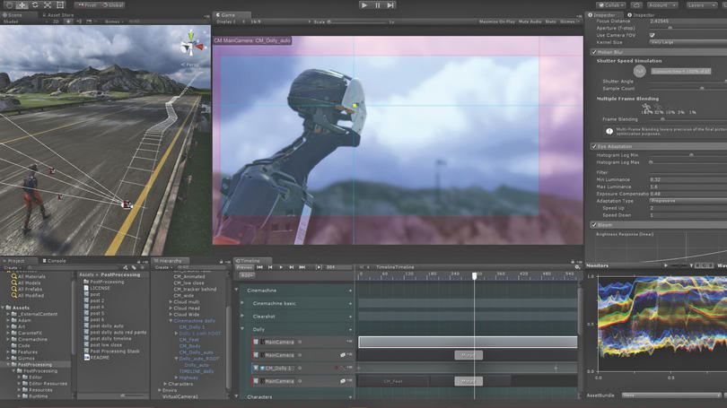

**Fig 6:** Unity Layout Using Cinemachine & Timeline

These scenes, using assets from the unity asset store, were developed from an initial storyboard to demonstrate the impact of air pollution (see Fig 7).

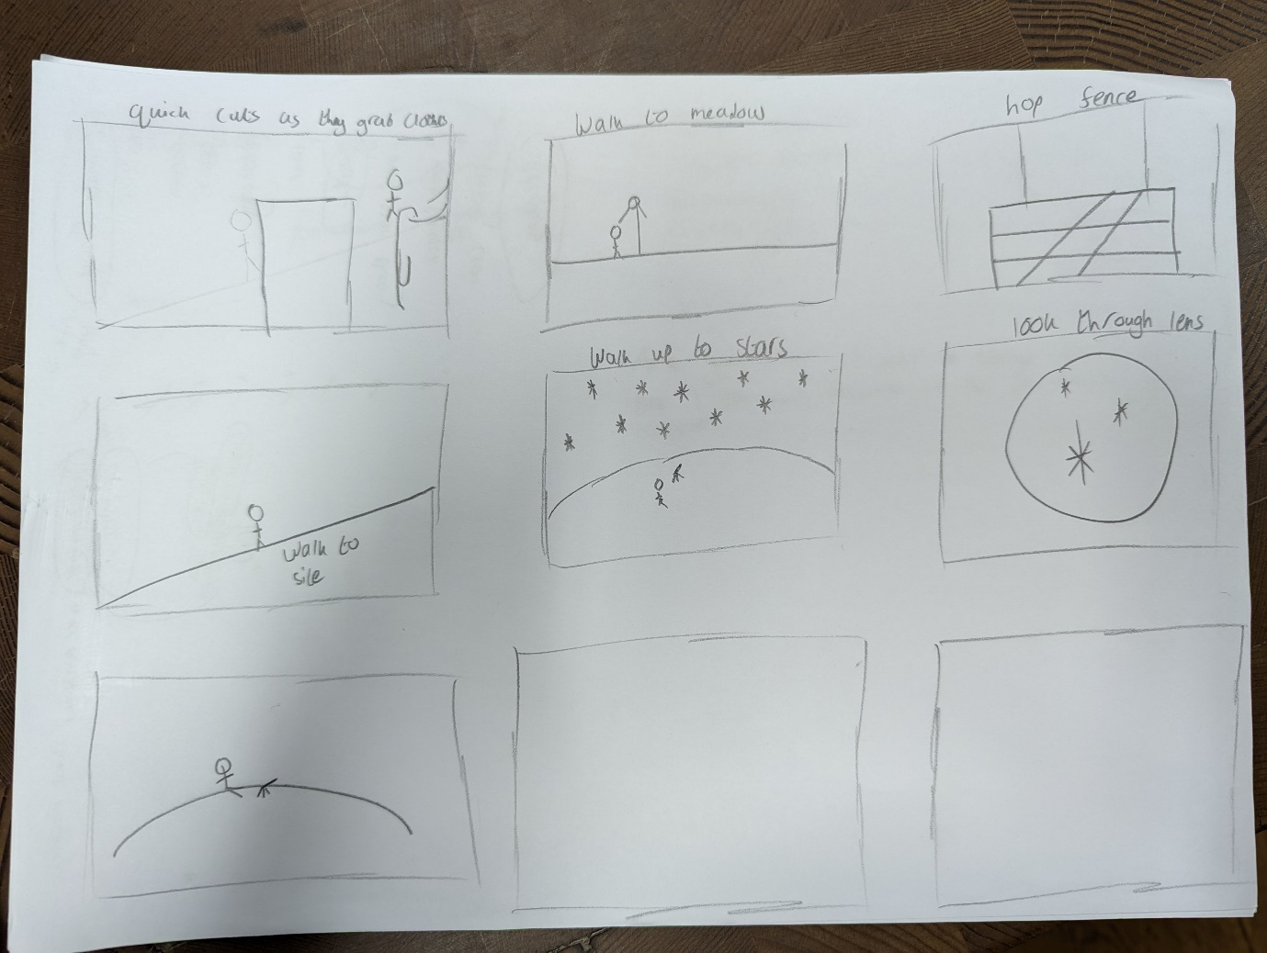

**Fig 7:** Air Pollution Storyboard

**5.3.1. Pilot testing**

Following the creation of the initial video (see Fig 8), the project ran a pilot test with two participants. During the view time of the video, they were informed of the intention and conceptual idea of the video. Feedback predominantly aimed towards the video not fulfilling its intention and was rather off course. The video had been unsuccessful and was in need of rework visually but more importantly conceptually. It was clear from the viewing; viewers fundamentally struggle with seeing the positives to air pollution as a topic but also the video did not deliver that was the message. This was significant as it implied the cinematography and digital marketing techniques were not established in a way that influenced the narrative.



**Fig 8:** Shots from Air Pollution Videos

**5.4. Design brief, user personas & storyboards**

The original idea of air pollution was changed to a more empathetic issue, animal captivity within Zoos. Taking inspiration from a user experience approach, a design brief was created to keep thoughts on track as well as towards a specific agenda (see Fig 9).

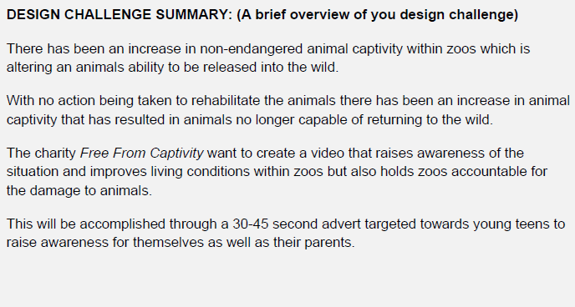

**Fig 9:** Design Challenge Summary from Design Brief

The idea of establishing a purpose for the advert was taken a step further by creating a fictional charity, *Free From Captivity*. This allowed for a targeted approach towards the advert, with a fixed goal/outcome. The process from this point involved creating user personas towards the target audiences as well as the charity itself. The goal for the advert is to educate the personas as well as influence their decision to engage with the issue (see fig 10).

• Free From Captivity – a charity seeking to increase awareness of the benefits and pitfalls of zoos. Being a very modern and social media heavy company, they are seeking a video to be accessed across all platforms.

• Caroline Shaw – a parent who cares for their children, she doesn’t want them to be shown harmful content.

• Rebecca Cloud – a young teen who loves animals and the world around her who often watches tv to see glimpses of animals in her favourite shows. Typically asks her parents for objects/activities advertised on the TV.

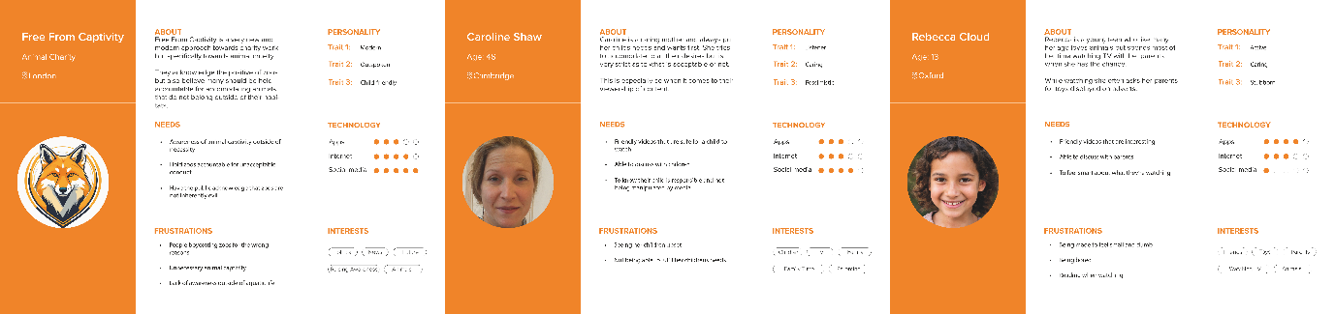

**Fig 10:** User Personas

A decision was made to create one video, which will showcase both sides of the story rather than two contrasting videos. The reasoning behind one video was a result of the previous user testing which demonstrated that two contrasting videos were potentially not effective if neither point can come across to the viewer. Instead, one video allows for digital marketing and cinematograph to display their ability to influence a narrative in one sitting. Additionally, this avoids potentially biased answers in user testing as users will interpret two videos as contrasting and perhaps answering questions in the way the project desires. Therefore, the narrative will display that zoos are enjoyable and there is no guilt for going to one and seeing exotic animals (see Fig 11). However, the dark undertones such as poor animal conservation and living conditions should be considered. The intended advert will be reminiscent of Video 5 – No Genre. Although, utilising the personas and design brief, the video will contrast in a more formatted way, as stated by Dmytryk videos should only change when necessary (Frierson, 2018). Taking into consideration feedback from participants, such as Participant H saying, “if you wanted to escalate it, do it gradually. If you wanted to go from greyscale to colour… leak in colour.”

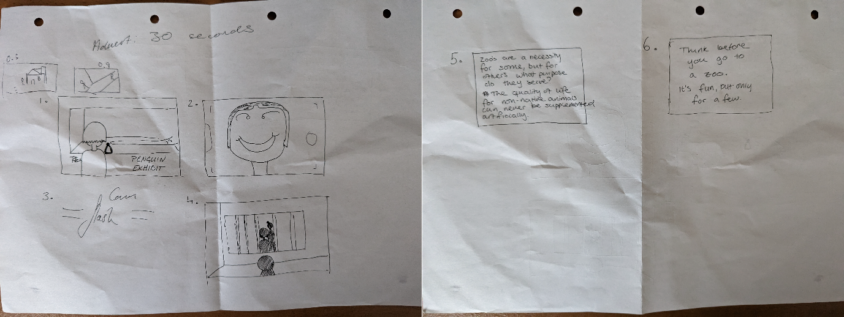

**Fig 11:** Visiting Zoo Storyboard

The advert is designed to air during children tv to target the youth, by influencing their thoughts on the matter they will push for change, thus influencing the true target audience - parents. Parents/adults are the true people who can bring about change to the situation, however, to get them to move they need a strong catalyst – children. Following the user personas, the parent likes to accomplish their child’s aspirations and therefore, hitting an easily influential audience will achieve the main goal of reaching the parent. For this to happen an emotional response will need to be triggered within the children inside of a 30-45 second timespan as that is the length of the advertisement. In this timespan, a problem needs to be suggested, accompanied by a call to action for the children to seek their parent.

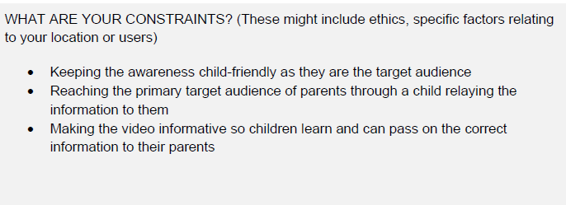

**Fig 12:** Design Constrains from Design Brief

While the narrative and outcome have been considered, the project faces a few ‘constraints’ (see Fig 12). The advert needs to be child friendly as to not scare the children from never going to zoos as that is not the intention. Additionally, this would neglect the needs of a parent’s user persona, due to wanting to keep their child safe. The video should instead engage a child’s love for animals as well as play on their desire to make change, resulting in parents fulfilling their child’s desire.

**5.5. Advertisement**

The narrative plot for this story was kept simple but engaging. The video appears to start as a Zoo advertisement, pushing for the audience to visit their Zoo, however a twist in the action at the end of the story displays the unfortunate circumstances of the penguin. The tonal shift is accompanied by different lighting, created within Unity (see Fig 13).



**Fig 13:** Zoo Colouring Visual Contrast

The final video was created using a mixture of Adobe Premier Pro and After Effects (Adobe, 2024), similarly to the videos created for SIFU. Following the events of the storyboard and the emotional points that needed to be hit, the editing was used in a way to exaggerate shots through the use of colour changing/grading as well as motion graphics for transitions. This was concluded after the previous pilot testing for the air pollution videos, where the main point of feedback was a lack of narrative and emotional response. To not miss such pivotal aspects for the next video, elements were pushed to their limits. For instance, colouring was used in a contrasting way to convey the intended emotions, accompanied by suitable music and sounds, which reflected and elevated the on-screen action. This was a direct result of the user testing stated earlier, by oversaturating one element it can guide a user’s attention and steer it towards the intended message.

One such instance can be seen when accentuating the tonal difference in Fig 13. While already clear, emphasising the lighting through further colour grading brings a more impactful message to the audience (see Fig 14), this was reinforced when pilot testing was run for this scene and the green lighting in the shot of the penguin was requested to be decreased due to the colour being rather ominous.



**Fig 14:** Zoo Colouring Visual Contrast After Post-Production

Wanting to make the scene more empathetic and relatable to the audience dialogue was added to the human characters to verbally showcase their excitement and amazement of their surroundings. This juxtaposes the penguin’s narrative of silence, the only sound to be heard is the non-diegetic sound of music.

**5.6. User testing**

The results from user testing demonstrate that the implementation and exaggeration of elements added post-production were of powerful effect. One participant stated, “The different tones of blue help to add both joy (through the light blue) to the scene as well as the sadness through the dark blue/black of the penguin scene.” This opinion was rather unanimous and supports the decision to alter the colouring and lighting of the scene. Rather conclusively, many of the users thought the video achieved its required goal and in a very accessible manner. A common thought from users was worded elegantly by this user in particular, “the dark lighting in the final scene was very sad. It was also a sharp flip to invert the perspective from the people to the penguin. This completely changed the tone of the film.”

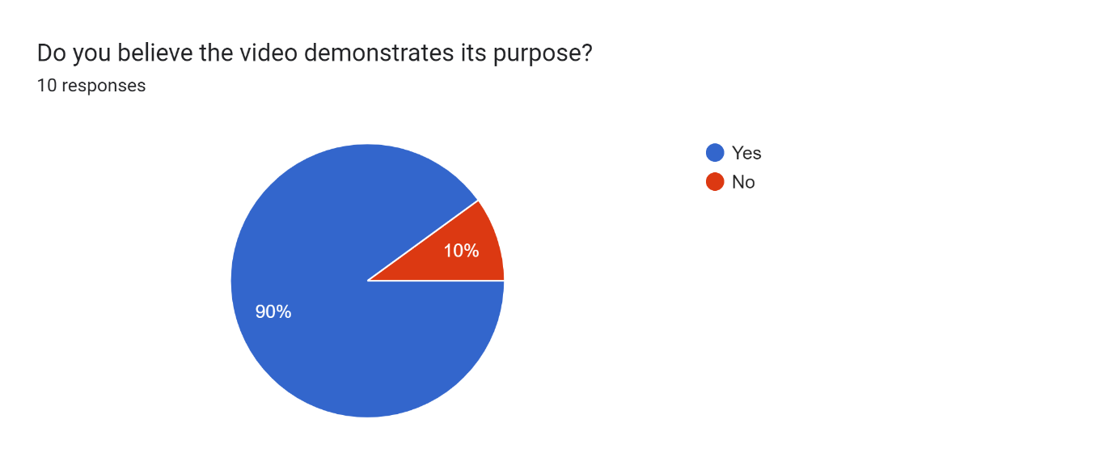

**Fig 15:** Pie Chart Display Results from User Testing

Overall, the results of the video seemed rather positive, and it appears to have hit the desired outcome. However, the narrative was misunderstood by many because of the final dark twist at the end. While the contrast of the video did induce thought and understanding of animal cruelty, it had not informed the audience that there should be no guilt in visiting zoos to see their favourite animals. Many took the video as awareness to boycott zoos rather than stand-up for the zoos and the animals. Therefore, a required change for the video would be the beginning portion and creating an atmosphere of welcoming, this can be reiterated in the final portion of the video which contains text informing users of the current situation.

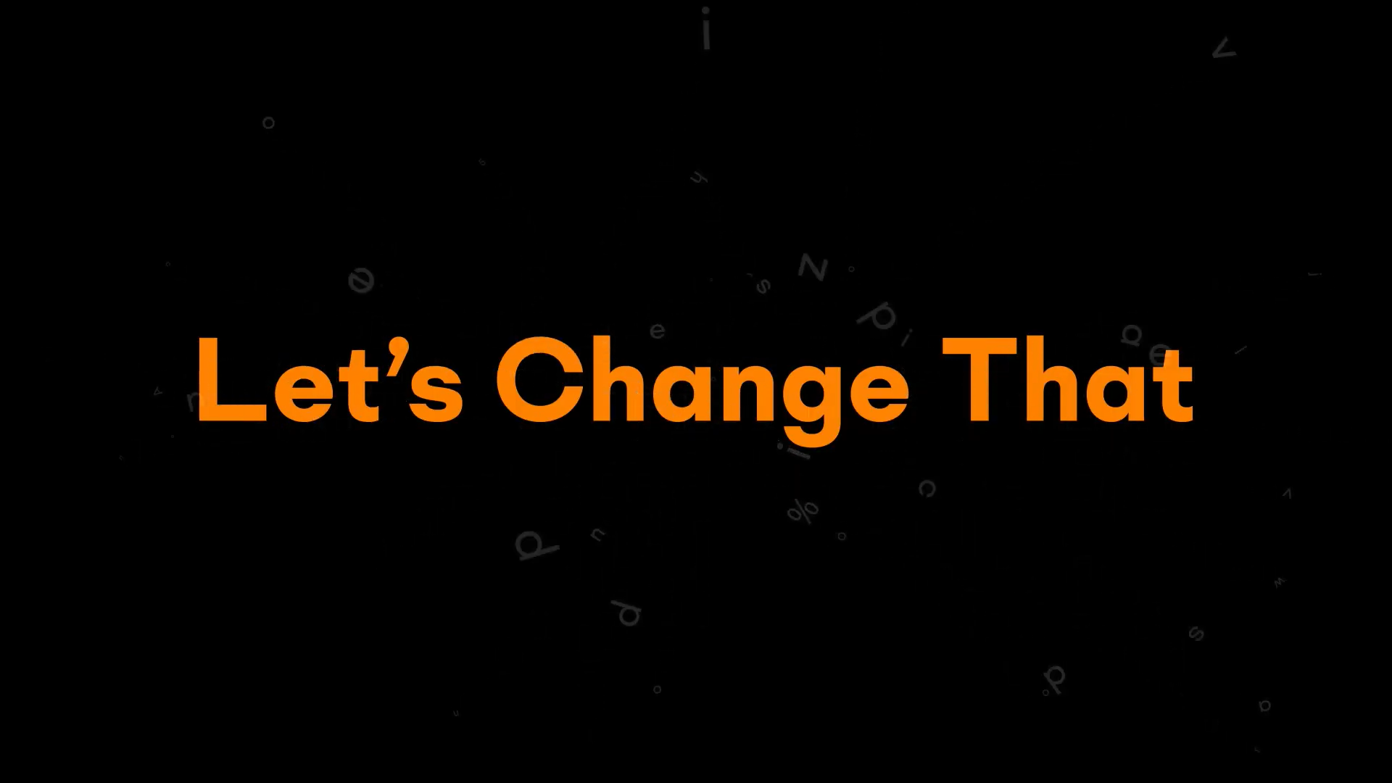

**Fig 16:** Display of Text from Free From Captivity Advertisement Video

**6. Discussion of outcomes**

Ultimately, the goal for the project was to manipulate a narrative using elements from cinematography working in collaboration with marketing techniques. This was initially achieved through the first artifact demonstrating cinematic elements altering a set narrative to change perception on how the actions are perceived. This is significant as it fundamentally showcases the effect cinematography holds upon a narrative, but it needed to be taken a step further and encompass the marketing techniques to gear the narrative in a linear manner. Such ideology was displayed and achieved through the final artifact, which had foundations within marketing and mainly propaganda as a marketing tool. The final video onboarded the approach of a target demographic, derived from marketing techniques, to steer the narrative. Therefore, leveraging more control of the cinematic elements that needed usage to manipulate a narrative.

The conceptual part of this project was procured from secondary research in the field, which the project works as a way of validating these findings. It reinforces the concepts of cinematography and its usage in video to draw on people’s emotional responses to specific techniques. One such example utilised in this project is, saturated colours feeling happier and inviting, in comparison to desaturated colours which have connotations to more depressing feelings and creating a sense of unease. While this is just one example, the project has its foundations in the research from the marketing and cinematography fields, which it upholds their findings and showcases them to full effect.

Additionally, the project contributes towards these fields by employing user experience methods to gather primary research and data. While this data supports research in the field, it also is an addition to the argument created from the sources of this project.

**6.1. Response to research questions**

As previously established the overall goal of the project was achieved, and alongside it, the research questions had been answered. The creation of a narrative was explored, using cinematography to immerse the audience in their viewing and withdraw emotional responses. Cinematic practises were used at all stage of creation, from initial recording to post-production video editing. The significance of post-production as a tool was exhibited by the initial videos, which were predominantly altered cinematically through post-production software’s to produce engagement within the audience. These were recorded by making use of the best suited UX methodologies. In this case, focus groups, interviews and surveys were applied to portray the emotional responses from users. Furthermore, the representation of these findings was created in a manner to work succinctly within the cinematography field as well as be viewed in a variety of forms best suited for the potential readers preference.

In addition, various forms of marketing tools were explored and placed in comparison to video. While video may not be as strong as a tool as blogs (Deiss & Henneberry, 2020), it is becoming increasingly influential in the modern world (Chaffey & Ellis-Chadwick, 2022). The project aimed to develop this growth by applying cinematography to video and create an emotional piece which stands equal with image. This was done so by exercising current marketing/digital marketing techniques but also taking influence from past ones, such as early propaganda.

While the project has proven the capabilities of cinematography and marketing working collaboratively, it has not explored the possibility of all marketing techniques. This would need a more focused project towards individual marketing tools as well as a bigger pool of users to derive data from. Therefore, another methodology process, which focused more on data gathering could have been a more efficient approach for this specific goal. This is due to the need for more quantitative data whereas this project aimed for more qualitative data. As a result, the project produced a finite amount of data to effectively answer whether cinematography and marketing of all forms can produce a successful product. However, as stated the research demonstrates that cinematography can be used alongside digital marketing for triggering emotional responses within users.

**6.2. Evaluation of approach**

The project successfully achieves its ultimate goal, however there are a few areas which could be improved for a more significant conclusion.

**6.2.1. Small scale findings**

The findings for this project, while showcasing the capabilities of cinematography and digital marketing as collective tool, is solely proven on a small scale. This may potentially question the results in a readers mind due to it lacking quantitative data. Therefore, the project would require a larger pool of participants to perhaps validate its findings. While not necessary, this may reassure potential researchers into trusting the project as a reliable source. However, that would be the next stage in the project as the current state focuses on qualitative data.

**6.2.2. Proficiency in Unity**

As Unity is not a strong skill of the researchers, the project potentially did not have sufficient development resources for producing a publishable advertisement. However, the graphics quality and animation of the scene were not the focus of the project. Whilst Unity is a great software for approaching this project, attributable to the accessibility and freedom to allow for artistic expression. Future studies with a wider range of professional resources could allow for improved camera control and editing methods. This could potentially amplify the findings stated in this report.

**6.2.3. Cinematography**

The project acknowledges, that the cinematography highlighted is not all the elements that is utilised when creating cinema. It uses the concepts as the main foundation and thus produces results from it. This project could be escalated by a future researcher within the film field to produce a piece that is well executed, employing the cinematic elements featured in this project as well as others that have been overlooked. A project such as this may benefit from a larger research team with a wider range of specialties, particularly in marketing allowing the project to make strides towards a definitive answer as to whether leveraging cinematography for effective digital marketing. Nonetheless, the project provides an answer that is conclusive, which utilises forms of cinematography and marketing.

**6.3. Alternative approaches**

While the artifacts created for this project fulfilled their intended objectives, there was a multitude of ways to come to the conclusion. Such methods were briefly mentioned previously, like recording in-person shots or recreating trailers from existing clips. The reason the project avoided these approaches were for copyright and resource reasons. While in-person recording can convey more emotional responses, due to instant connection with real people on-screen. The producer would need to scout believable actors, scenery as well as develop good mise-en-scene (arrangement of scenery and props on a screen/stage), alongside recording and editing the project. Although, this could make for a more believable narrative and induce marketing techniques better. Therefore, as an alternative approach it could possibly fulfil the desired outcome of the project in a more emotional influential way.

Similarly, the usage of SIFU was an effective method for supporting secondary research, however, the original intention of using Maya, may have been a more fruitful showcase of cinematography. Thus, creating another approach to validating the findings. Maya would have allowed for an unbiased original genre and successfully showcase the individual capabilities of cinematography with numerous videos showcasing specific elements, reminiscent of the SIFU videos. While, possibly time consuming in creating animations and potential models, the freedom possible with camera and lighting would have worked more effectively than the restricted usage of it in SIFU.

Lastly, the final artifact could successfully display the combination of marketing and cinematography through a variety of video ideas without some reliance on text. Having videos purely video and removing text can make for a heavy hitting narrative as users draw their own conclusions from an open narrative. Another idea is creating two videos instead of the one to truly exhibit two contrasting narratives and finding if the audience is swayed to one or the other. This could be similarly done for two videos displaying the same narrative and again finding the one that has big pull factor. While these are compelling narratives, by giving an audience two videos, you force them to compare. This could possibly lose the effective marketing side of the project due to them being inclined to answering user testing how they perceive you want them to answer. Therefore, another approach could be the creation of one video, showcasing a concept that is inherently negative. The challenge being to manipulate/influence the narrative to appeal to the audience and make them second guess their judgement. However, this may have a few ethical issues attached to such a concept.

**7. Conclusion and recommendations**

Predominantly, the project was successful in its findings and reiterating the effective collaboration of digital marketing and cinematography in influencing a narrative. This is evident from the results of user testing in the initial artifact stage but primarily from the final artifact where nine out of ten participants stated, the video demonstrated the intended purpose of influencing a narrative (see Fig 17).

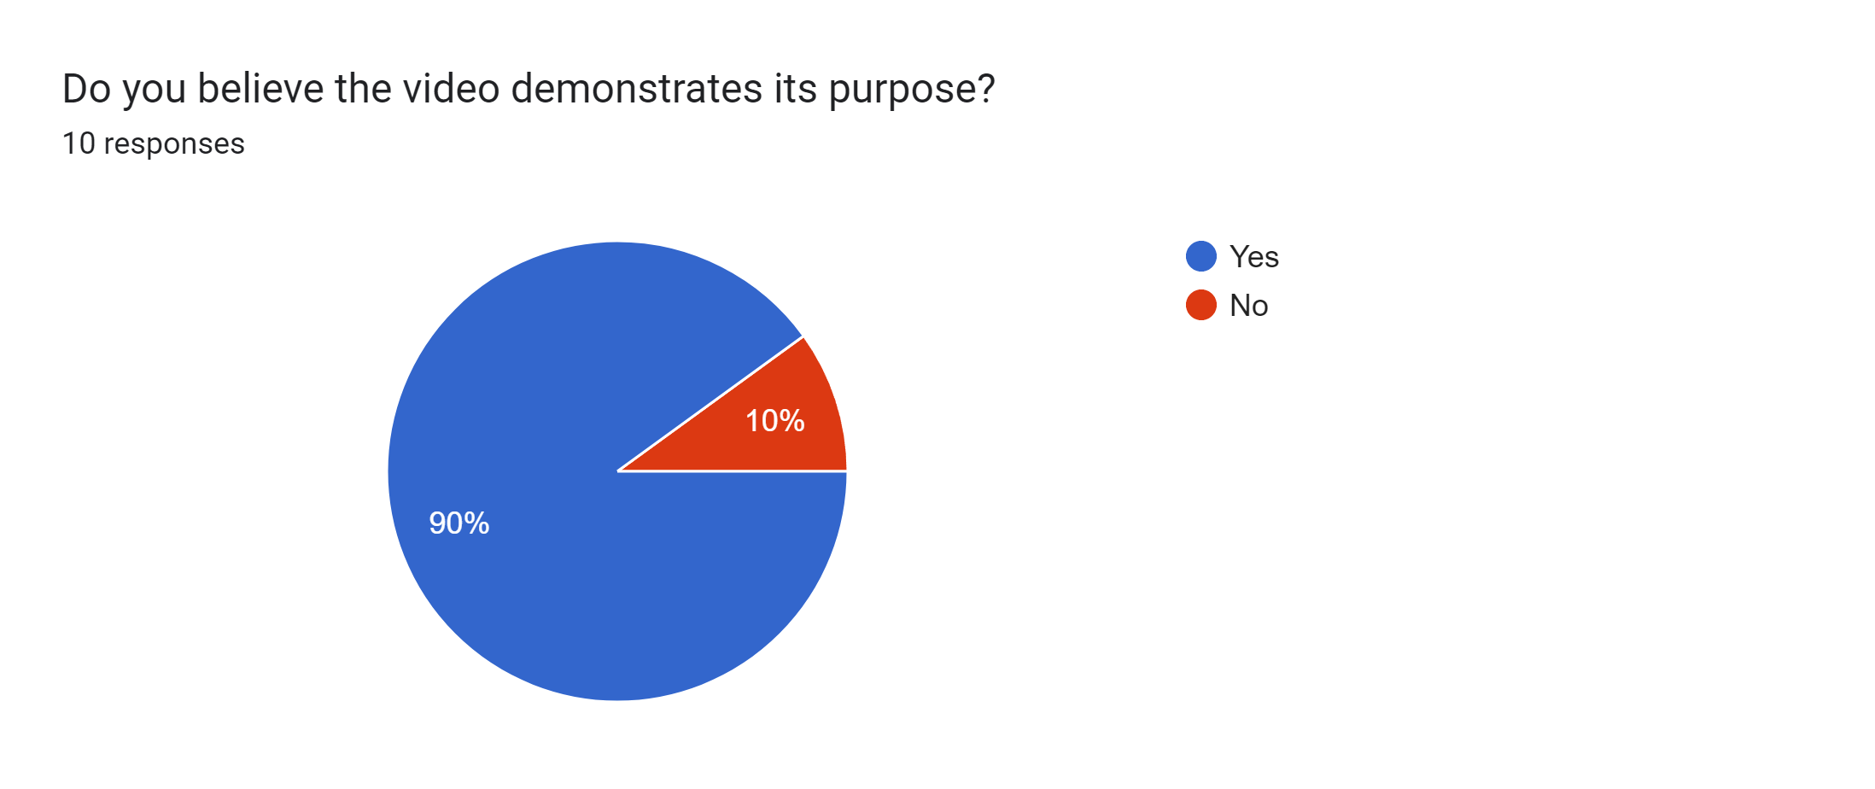

**Fig 17:** Responses from google forms survey

Furthermore, when asked if participants could expand on their understanding of the video, many provided an in-depth explanation into the goal of the video. Additionally, a few participants acknowledged the subversion of expectations to create an emotional response through the usage of colouring and sound.

This project lays the foundations for a full marketing strategy due to the creation of a design brief and user personas, the only fundamental aspect missing is a competitor analysis which was out of scope. Once these have been completely established a new or extended approach to the project could be taken. Another such approach could be furthering the development of *Free From Captivity* by mixing the cinematography with various other media outlets, such as graphics or blogs. This in turn would also fulfil the last research question which was not satisfied.

Building upon this, the approach could take a six-month project plan which could allow for the creation of a fictional social media page where similar videos are created every two weeks, alongside various other content. This will not only garner a bigger research capacity, due to having the internet as users but also will allow for authentic marketing results derived from videos influenced by cinematography. Moreover, a second account could be made, highlighting the same issues but using either different content besides video or perhaps a video only account which intentionally subverts or neglects the usage of cinematography.

On a wider scale, this project can be used to reaffirm the current understanding of cinematography. Additionally, the project provides another input and source towards cinematic elements as a summary of all, rather than an individual look at each element. Furthermore, providing another outlook on marketing and video being used cooperatively and how effective it can be used on a smaller scale. This would also allow another to approach the project and potentially upscale it, using the method stated above or through a new approach.

The results from this could possibly clarify whether cinematography for video marketing is effective, as well as the usage of video as marketing in general is an effective tool. This could allow for quicker decision making in a business environment. Due to being able to identify, whether the approach of video is useful to their marketing needs or another approach is more suitable.

Overall, the project provides an answer that leveraging cinematography can be used for effective digital marketing. While this is indicated on a small scale, it can easily be upscaled and provide a more elaborate answer to the findings of this project. These findings will further reinforce the secondary research conducted into cinematography and digital marketing as well as provide enough evidence to support the conclusion of this project.

**8. References**

Adobe (2024) *After Effects* (2024) [computer program]. Available from: <https://www.adobe.com/uk/creativecloud/renew/resubscribe-cci.html?gclid=Cj0KCQjw8pKxBhD_ARIsAPrG45nUD8rIzHABcB5C2oKwoUGi_oAUITY-eVF2q2aL8h_5fsk8AVRnaPAaAnX4EALw_wcB&mv=search&mv=search&mv2=paidsearch&sdid=F89JZKCP&ef_id=Cj0KCQjw8pKxBhD_ARIsAPrG45nUD8rIzHABcB5C2oKwoUGi_oAUITY-eVF2q2aL8h_5fsk8AVRnaPAaAnX4EALw_wcB:G:s&s_kwcid=AL!3085!3!436521414954!e!!g!!adobe%20after%20effects!10105625998!106997350968&gad_source=1> [Accessedm 26 December 2023].

Adobe (2024) *Premier Pro* (2024) [computer program]. Available from: <https://www.adobe.com/uk/creativecloud/renew/resubscribe-cci.html?gclid=Cj0KCQjw8pKxBhD_ARIsAPrG45ljBmCU7ir9P8ZGMwZXjXusHK8ZX1YZyEJXwWcWNo1JpgRLsV54T0IaAlukEALw_wcB&mv=search&mv=search&mv2=paidsearch&sdid=F89JZKCP&ef_id=Cj0KCQjw8pKxBhD_ARIsAPrG45ljBmCU7ir9P8ZGMwZXjXusHK8ZX1YZyEJXwWcWNo1JpgRLsV54T0IaAlukEALw_wcB:G:s&s_kwcid=AL!3085!3!436521415398!e!!g!!adobe%20premiere%20pro!10105625998!106997352368&gad_source=1> [Accessed 26 December 2023].

BBC Maestro (2023) What is the difference between diegetic sound and non diegetic sound. *BBC Maestro* [online]. [Accessed 21 April 2024].

Bernays, E. (1928) *Propaganda* [online]. Horace Liveright [Accessed 28 January 2024].

Bernays, EL. Miller, MC. (2005) *Propaganda* [online]. Brooklyn, N,Y:Ig Pub. [Accessed 28 January 2024].

Chaffey, D. Ellis-Chadwick, F. (2022) *Digital Marketing* [online]. Eighth Edition. Harlow: Peason Education, Limited. [Accessed 28 January 2024].

Creative Path Films (2020). Color Temperature & Emotion | Film Lighting Techniques. *YouTube* [video]. 20 November. Available from: https://www.youtube.com/watch?v=A_aymULfI1Y [Accessed 18 November 2023].

DefinitelyOwen (2016). How To Convey Emotion Through Cinematography. *YouTube* [video]. 08 December. Available from: https://www.youtube.com/watch?v=8_ZZBUhICwE [Accessed 18 November 2023].

Deiss, R. Henneberry, R. (2020*) Digital Marketing* [online]. Hoboken, New Jersey: For Dummies. [Accessed 28 January 2024].

EriksenTranslations (2020) How Translating Colors Across Cultures Can Help You Make a Positive Impact. *EriksenTranslations* [online]. [Accessed 21 April 2024].

Frierson, M. (2018) *Film and Video Editing Theory: How Editing Creates Meaning* [online]. Milton: Routledge. [Accessed 22 November 2023].

Jackson, C. (2010) *Flash Cinematic Techniques: Enhancing Animated Shorts and Interactive Storytelling* [online]. Oxford: Routledge. [Accessed 22 November 2022].

Murch, W. (2001) *In the blink of an eye: a perspective on film editing* [online]. Los Angeles, California: Silman-James Press. [Accessed 22 November 2023].

Nielsen, J (1997) The Use and Misuse of Focus Groups. *Nielsen Norman Group* [online]. [Accessed 24 October 2023].

Nielsen, J. (2012) Thinking Aloud: The #1 Usability Tool. *Nielsen Norman Group* [online]. [Accessed 24 October 2023].

OxfordLanguages (2024) *Oxford Languages*. Available from: https://languages.oup.com/ [Accessed 18 April 2024].

Pixaby (2024) *Pixaby Terms of Service*. Available from: https://pixabay.com/service/terms/ [Accessed 18 April 2024].

Pixaby (2024) *Stunning royalty-free images & royalty free-stock.* Available from: https://pixabay.com/ [Accessed 26 December 2023].

Risk, M. (2020). How to Use Color in Film: 50+ Examples of Movie Color Palettes. *StudioBinder* [blog]. 27 July. Available from: https://www.studiobinder.com/blog/how-to-use-color-in-film-50-examples-of-movie-color-palettes/ [Accessed 22 November 2023].

StudioBinder (2020). Ultimate Guide to Camera Angles: Every Camera Shot Explained [Shot List, Ep. 3]. *YouTube* [video]. 29 June. Available from: https://www.youtube.com/watch?v=wLfZL9PZI9k [Accessed 18 November 2023].

StudioBinder (2022). Ultimate Guide to Cinematic Lighting – Types of Light & Gear Explained [Shot List Ep. 12]. *YouTube* [video]. 24 October. Available from: https://www.youtube.com/watch?v=r2nD_knsNrc [Accessed 18 November 2023].

Thomas, B (2020) *Watertight Marketing: The Proven Process for Seriously Scalable Scales* [online]. Second Edition. Human Business Thinking. [Accessed 20 January 2024].

Tomorrows Filmmakers (2018). Aspect Ratios | Tomorrow’s Filmmakers. *YouTube* [video]. 16 November. Available from: https://www.youtube.com/watch?v=BdPsyLtlamM [Accessed 21 November 2023].

Yang, Y. and Chen, H. (2011) *Music emotion recognition* [online]. Boca Raton, Fla. : CRC ; London : Taylor & Francis distributor. [Accessed 22 November 2023].

**9. Bibliography**

Angus Davies (2021). How To Create Emotion In Cinematography. *YouTube* [video]. 15 May. Available from: https://www.youtube.com/watch?v=mWkjmRG5bp0 [Accessed 18 November 2023].

Atwell, P. (2017) *What is the resolution of the movies in large theaters (seating more than 300)?.* Available from: https://www.quora.com/What-is-the-resolution-of-the-movies-in-large-theaters-seating-more-than-300 [Accessed 27 December 2023].

Bence Mervay (2022) Make a Unity cinematic in 5 minutes! - Tutorial - Unity, Davinci Resolve. *YouTube* [video]. 03 September. Available from: https://www.youtube.com/watch?v=1MNCG4bSSM4 [Accessed 16 March 2024].

Creative Path Films (2020). Color Temperature & Emotion | Film Lighting Techniques. *YouTube* [video]. 20 November. Available from: https://www.youtube.com/watch?v=A_aymULfI1Y [Accessed 18 November 2023].

Djisso (2022) [Sifu] How To Use The Replay Editor - Easy Guide. *YouTube* [video]. 12 December. Available from: https://www.youtube.com/watch?v=FfkKkjZcHt4&t=648s [Accessed 21 December 2023].

Dmytryk, E. (1984) *On film editing: an introduction to the art of film construction* [online]. Boston: Focal Press. [Accessed 22 November 2023].

Film Riot (2020). Cinematography Basics: The Emotion of Color. *YouTube* [video]. 10 December. Available from: https://www.youtube.com/watch?v=JpCmnN0ijUc [Accessed 18 November 2023]

FXhome (2019). Understanding basic camera shot psychology. *YouTube* [video]. 10 April. Available from: https://www.youtube.com/watch?v=ITYLbETI0u8 [Accessed 18 November 2023].

Hendershot, N (2023) Propaganda. *Journal of Intersectionality* [online]. 7(1), pp. 69-71. [Accessed 28 January 2024].

iHeartGameDev (2021) How to use Cameras in Unity: Cinemachine Overview and Brain Explained!. *YouTube* [video]. 05 December. Available from: https://www.youtube.com/watch?v=P_ibDJhFVMU [Accessed 16 March 2024].

iHeartGameDev (2022) How to use Cameras in Unity: Cinemachine Virtual Cameras Explained. *YouTube* [video]. 22 January. Available from: https://www.youtube.com/watch?v=asruvbmUyw8 [Accessed 16 March 2024].

Knibbs, J. (2023) Number of visible stars drastically falling, warns study, as ‘skyglow’ affects night sky. *The Standard* [online]. 20 January. Available from: https://www.standard.co.uk/news/visible-stars-drastically-reduced-skyglow-pollution-b1054495.html [Accessed 29 February 2024].

Mulier, L. Slabbnick, H. Vermeir, I. (2021) This Way Up: The Effectiveness of Mobile Vertical Video Marketing. *Journal of Interactive Marketing* [online]. 55 (1), pp 1-15. [Accessed 28 January 2024].

Norman, D.A (1998) *The Design of Everyday Things* [online]. London: MIT. [Accessed 26 October 2023].

Royal College of Art (2023) *Reflections on Inclusivity: Design Inclusive with Patricia Moore*. Available from: https://www.rca.ac.uk/news-and-events/news/design-inclusive-with-patricia-moore/ [Accessed 26 October 2023].

Sloclap (2022) *SIFU.* Standard Edition[Video Game]. Sloclap. Available from: <https://www.xbox.com/en-US/games/store/sifu/9p7pf6zp3958> [Accessed 21 December 2023].

SmartAir (2024) *Does Air Pollution Have Any Advantages?.* Available from: https://smartairfilters.com/learn/smart-air-knowledge-base/does-air-pollution-some-advantages/ [Accessed 29 February 2024].

Tasner, Michael (2011) *Video marketing taking video to the next level* [online]. N.J.:FTPress Delivers. [Accessed 15 January 2024].

The Canvas (2023) A Guide to Propaganda. *YouTube* [video]. 29 January. Available from: https://www.youtube.com/watch?v=8i_Zw1Itv40 [Accessed 28 January 2024].

The Verge (2015). How filmmakers manipulate our emotions using color. *YouTube* [video]. 11 Ocotober. Available from: https://www.youtube.com/watch?v=0ZZgiSUyPDY [Accessed 18 November 2023].

Unity (2017) Using Cinemachine: Getting Started. *YouTube* [video]. 27 November. Available from: https://www.youtube.com/watch?v=x6Q5sKXjZOM [Accessed 16 March 2024].

World Health Organisation (2024) *Air Pollution*. Available from: https://www.who.int/health-topics/air-pollution#tab=tab_1 [Accessed 29 February 2024].

**Appendix A: Project Log**

|  |  |
| --- | --- |
| **Task** | **Date** |
| Cinematography research | 13/11/2023 - 27/11/2023 |
| Scene creation | 29/11/2023 – 22/12/2023 |
| Scene editing | 26/12/2023 – 28/12/2023 |
| User testing | 01/01/2024 – 15/01/2024 |
| Marketing research | 24/01/2024 – 29/01/2024 |
| Unity creation | 06/02/2024 – 28/03/2024 |
| Video editing | 28/03/2024 – 01/04/2024 |
| User testing | 01/04/2024 – 08/04/2024 |
| Report | 07/04/2024 – 25/04/2024 |

**Appendix B: Project Timeline**

**Appendix C: Assets used in the Project**

The assets listed below do not belong to me and were sourced from a variety of sites.

Pixaby - licensed under the Creative Commons Zero (CC0) licence (CC0 Content):

* 1stop-it-audio-clip-100732 (2024) *Pixabay* [download] Ulm, Germany: Pixabay
* Amaksi (2022) *Stomp. pixabay* [download] [Accessed 27 December 2023].
* atm_int_officelesscompshighwindoutsiderej_st_f8mkh41670-25819 (2024) *Pixabay* [download] Ulm, Germany: Pixabay
* atmosphere-dark-3-16803 (2024) *Calm background for video. Pixabay.* [download] [Accessed 30 March 2024].
* calm-background-for-video (2024) *Calm background for video. Pixabay.* [download] [Accessed 30 March 2024].
* cameraflashmp3-14565 (2024) *Pixabay* [download] Ulm, Germany: Pixabay
* concrete-footsteps-1-6265 (2024) *Pixabay* [download] Ulm, Germany: Pixabay
* concrete-footsteps-6752 (2024) *Pixabay* [download] Ulm, Germany: Pixabay
* concrete-hallway-with-air-conditioner-17139 (2024) *Pixabay* [download] Ulm, Germany: Pixabay
* crowded-avenue-people-talking-vendors-shouting-musicians-playing-part-1-7099 (2024) *Pixabay* [download] Ulm, Germany: Pixabay
* crowd_talking-6762 (2024) *Pixabay* [download] Ulm, Germany: Pixabay
* emergency-alarm-with-reverb-29431 *Pixabay* [download] Ulm, Germany: Pixabay
* female-greetingswav-14750 (2024) *Pixabay* [download] Ulm, Germany: Pixabay
* funny-yay-6273 (2024) *Pixabay* [download] Ulm, Germany: Pixabay
* girl-chucklewav-14669 (2024) *Pixabay* [download] Ulm, Germany: Pixabay
* goodbye-48279 (2024) *Pixabay* [download] Ulm, Germany: Pixabay
* grunt-85990 (2024) *Pixabay* [download] Ulm, Germany: Pixabay
* Grand_Project (2020) *Sensual Jazz_Medium 1. Pixabay.* [download] [Accessed 31 December 2023].
* heyy-43849 (2024) *Pixabay* [download] Ulm, Germany: Pixabay
* horror-piano-hits-73998 (2024) *Pixabay* [download] Ulm, Germany: Pixabay
* i-dont-know-mate-96906 [download] Ulm, Germany: Pixabay
* in-the-belly-of-the-beast-18261 [download] Ulm, Germany: Pixabay
* Jplenio (2018) *Misty Memories – Gone. pixabay.* [download] [Accessed 30 March 2024].
* jumping-on-wooden-floor-41234 (2024) *Pixabay* [download] Ulm, Germany: Pixabay
* low-no-82600 (2024) *Pixabay* [download] Ulm, Germany: Pixabay
* man-says-astounding-186562 (2024) *Pixabay* [download] Ulm, Germany: Pixabay
* male_hurt7-48124 (2024) *Pixabay* [download] Ulm, Germany: Pixabay
* muffled-talking-6161 (2024) *Pixabay* [download] Ulm, Germany: Pixabay
* Music_For_Videos (2022) *Spy. pixabay.* [download] [Accessed 31 December 2023].
* oi-85782 (2024) *Pixabay* [download] Ulm, Germany: Pixabay
* ough-47202 (2024) *Pixabay* [download] Ulm, Germany: Pixabay
* out-of-breath-male-176715 (2024) *Pixabay* [download] Ulm, Germany: Pixabay
* punch-boxing-02wav-14897 (2024) *Pixabay* [download] Ulm, Germany: Pixabay
* pinguine-wasser-pltschert-61499 (2024) *Pixabay* [download] Ulm, Germany: Pixabay
* radio-static-6382 (2024) *Pixabay* [download] Ulm, Germany: Pixabay
* Rockot (2016) *Drive Breakbeat. pixabay*. [download] [Accessed 01 January 2024].
* Semchyshyn, Y (2021) *Catch It. Pixabay.* [download] [Accessed 31 December 2023].
* short-whoosh-13x-14526 (2024) *Pixabay* [download] Ulm, Germany: Pixabay
* slow-whoosh-118247 (2024) *Pixabay* [download] Ulm, Germany: Pixabay
* SergePavkinMusic (2017) *Summer Adventures. Pixabay.* [download] [Accessed 25 March 2024].
* talking-people-6368 (2024) *Pixabay* [download] Ulm, Germany: Pixabay
* thump-and-grunt-85606 (2024) *Pixabay* [download] Ulm, Germany: Pixabay
* tuning-radio-7150 (2024) *Pixabay* [download] Ulm, Germany: Pixabay
* UNIVERSFIELD (2022) *Dark Suspense For Trailers And Film. pixabay*. [download] [Accessed 01 January 2024]
* whoah-158050 (2024) *Pixabay* [download] Ulm, Germany: Pixabay
* whoosh-6316 (2024) *Pixabay* [download] Ulm, Germany: Pixabay
* whoosh-blow-flutter-shortwav-14678 (2024) *Pixabay* [download] Ulm, Germany: Pixabay
* whoosh-cinematic-161021 (2024) *Pixabay* [download] Ulm, Germany: Pixabay
* whoosh-drum-hits-169007 (2024) *Pixabay* [download] Ulm, Germany: Pixabay
* whoosh-transitions-sfx-03-118230 (2024) *Pixabay* [download] Ulm, Germany: Pixabay

Unity Asset Store – licencsed by Standard Unity Asset Store EULA:

* 255 pixel studios (2018) *POLYGON office building.* Available from: <https://assetstore.unity.com/packages/3d/environments/urban/polygon-office-building-82282> [Accessed 05 March 2024].
* ALP (2019) *Terrain Textures Pack Free.* Available from: <https://assetstore.unity.com/packages/2d/textures-materials/nature/terrain-textures-pack-free-139542> [Accessed 28 February 2024].
* ArtStudios3d (2021) *Playground Low Poly.* Available from: <https://assetstore.unity.com/packages/3d/environments/playground-low-poly-191533> [Accessed 28 February 2024].
* Droste, B (2011) *Stone Fence*. Available from: <https://assetstore.unity.com/packages/3d/props/exterior/stone-fence-2437> [Accessed 05 March 2024].
* ChermandirKun (2016) *Town Houses Pack.* Available from: <https://assetstore.unity.com/packages/3d/environments/urban/town-houses-pack-42717> [Accessed 28 February 2024].
* Ithappy (2023) *Animals FREE.* Available from: <https://assetstore.unity.com/packages/3d/characters/animals/animals-free-260727> [Accessed 28 March 2024].
* Kutsenko, D (2024) *RPG/FPS Game Assets for PC/Mobile (Industrial Set v3.0).* Available from: <https://assetstore.unity.com/packages/3d/environments/industrial/rpg-fps-game-assets-for-pc-mobile-industrial-set-v3-0-101429> [Accessed 28 February 2024].
* LB3D (2020) *School, Bus, Simple. Isometric.* Available from: <https://assetstore.unity.com/packages/3d/vehicles/land/school-bus-simple-isometric-106250> [Accessed 05 March 2024].
* LowlyPoly (2019) *Stylize Water Texture.* Available from: <https://assetstore.unity.com/packages/2d/textures-materials/water/stylize-water-texture-153577> [Accessed 28 March 2024].
* Made for Games (2020) *Industrial Models.* Available from: <https://assetstore.unity.com/packages/3d/props/industrial/industrial-models-171071> [Accessed 28 February 2024].
* Rpgwhitelock (2021) *AllSky Free – 10 Sky / Skybox Set.* Available from: <https://assetstore.unity.com/packages/2d/textures-materials/sky/allsky-free-10-sky-skybox-set-146014> [Accessed 28 February 2024].
* SpaceZeta (2023) *Street Lamps 2.* Available from: <https://assetstore.unity.com/packages/3d/props/exterior/street-lamps-2-260395> [Accessed 28 February 2024].
* Supercyan (2020) *Environment Pack: Free Forest Sample.* Available from: <https://assetstore.unity.com/packages/3d/vegetation/environment-pack-free-forest-sample-168396> [Accessed 28 February 2024].
* Versatile Studio (2024) *Demo City By Versatile Studio (Mobile Friendly).* Available from: <https://assetstore.unity.com/packages/3d/environments/urban/demo-city-by-versatile-studio-mobile-friendly-269772> [Accessed 28 February 2024].

Mixamo – licensed by Adobe:

* Mixamo (2024) *Amy.* Available from: <https://www.mixamo.com/#/?page=1&type=Character> [Accessed 28 March 2024].
* Mixamo (2024) *Crouch To Stand.* Available from: <https://www.mixamo.com/#/?page=1&query=crouch+to+stand&type=Motion%2CMotionPack> [Accessed 28 March 2024].
* Mixamo (2024) *Elizabeth.* Available from: <https://www.mixamo.com/#/?page=2&type=Character> [Accessed 28 March 2024].
* Mixamo (2024) *Excited.* Available from: <https://www.mixamo.com/#/?page=1&query=excited&type=Motion%2CMotionPack> [Accessed 28 March 2024].
* Mixamo (2024) *Happy idle.* Available from: <https://www.mixamo.com/#/?page=1&query=happy+idle&type=Motion%2CMotionPack> [Accessed 28 March 2024].
* Mixamo (2024) *Happy Right Turn.* Available from: <https://www.mixamo.com/#/?page=1&query=happy+right+turn&type=Motion%2CMotionPack> [Accessed 28 March 2024].
* Mixamo (2024) *Idle.* Available from: <https://www.mixamo.com/#/?page=1&query=idle&type=Motion%2CMotionPack> [Accessed 28 March 2024].
* Mixamo (2024) *Joyful Jump.* Available from: <https://www.mixamo.com/#/?page=1&query=joyful+jump&type=Motion%2CMotionPack> [Accessed 28 March 2024].
* Mixamo (2024) *Leonard.* Available from: <https://www.mixamo.com/#/?page=1&type=Character> [Accessed 28 March 2024].
* Mixamo (2024) *Standard Walk.* Available from: <https://www.mixamo.com/#/?page=1&query=standard+walk&type=Motion%2CMotionPack> [Accessed 28 March 2024].
* Mixamo (2024) *Waving Gesture.* Available from: <https://www.mixamo.com/#/?page=1&query=waving+gesture&type=Motion%2CMotionPack> [Accessed 28 March 2024].

Sketchfab - licenced by Creative Commons (CC by 4.0 deed):

* Huxley, A (2023) *Telescope.* Available from: <https://sketchfab.com/3d-models/telescope-9d1c5efb30f84a1282981efef66c6410> [Accessed 28 February 2024].
* Patick.young (2024) *Singapore Zoo.* Available from: <https://sketchfab.com/3d-models/singapore-zoo-7cf34b58d72d4c8db4eb3abf39aa3d60> [Accessed 28 March 2024].
* Sousinho (2022) *Scifi Corridor.* Available from: <https://sketchfab.com/3d-models/scifi-corridor-d1e7e355ac93430b816dbd914f5a8db9> [Accessed 28 March 2024].